# DriverPass System Design Document

## UML Diagrams

### UML Use Case Diagram

### UML Activity Diagrams

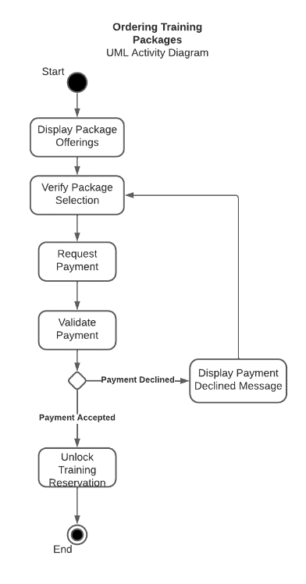

### Diagram Description automatically generatedUML Sequence Diagram

### UML Class Diagram

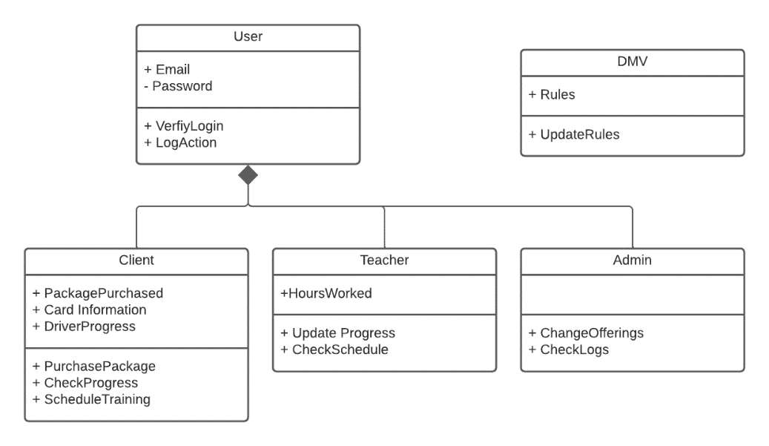

## Technical Requirements

This system design will need several technical systems to ensure that it runs properly. Firstly, it has been requested that the system operate from the cloud. A cloud service provider will need to be selected along with the appropriate allocation of resources to support the web-based system and all people who may use it at any given time. Since it was requested that the system be web-based, an appropriate domain name will need to be selected and secured. Aside from that, Administrative users will need to be trained on security practices as well as all system functions so they can provide user support. There will be a need for a secure method of password reset for when an account is locked. A Payment processing system will need to be selected so that we can integrate it into the system to process payments for training packages securely. Access to the DMV’s updates will need to be discussed and the method of notification of new updates to driving rules and regulations will need to be decided. Aside from these requirements, we will need to ensure that all desired functionality outlined in the DriverPass conversation is accounted for in the design and that all aspects outlined in the diagrams are implemented properly.